### 

### Semester Two Examination, 2020

### Question/Answer booklet

# MATHEMATICS SPECIALIST

**UNIT 1&2**

## Section Two:

## Calculator-assumed

Your Name

Your Teacher’s Name

## Time allowed for this section

Reading time before commencing work: ten minutes

Working time: one hundred minutes

## Materials required/recommended for this section

***To be provided by the supervisor***

This Question/Answer booklet

Formula sheet (retained from Section One)

***To be provided by the candidate***

Standard items: pens (blue/black preferred), pencils (including coloured), sharpener, correction fluid/tape, eraser, ruler, highlighters

Special items: drawing instruments, templates, notes on two unfolded sheets of A4 paper, and up to three calculators approved for use in this examination

## Important note to candidates

No other items may be taken into the examination room. It is **your** responsibility to ensure that you do not have any unauthorised material. If you have any unauthorised material with you, hand it to the supervisor **before** reading any further.

|  |  |  |  |  |  |
| --- | --- | --- | --- | --- | --- |
| **Question** | **Marks** | **Max** | **Question** | **Marks** | **Max** |
| **9** |  | **10** | **16** |  | **6** |
| **10** |  | **6** | **17** |  | **6** |
| **11** |  | **5** | **18** |  | **8** |
| **12** |  | **9** | **19** |  | **8** |
| **13** |  | **7** | **20** |  | **8** |
| **14** |  | **10** | **21** |  | **7** |
| **15** |  | **10** |  |  |  |

**Structure of this paper**

|  |  |  |  |  |  |
| --- | --- | --- | --- | --- | --- |
| Section | Number of questions available | Number of questions to be answered | Working time (minutes) | Marks available | Percentage of examination |
| Section One:  Calculator-free | 8 | 8 | 50 | 54 | 36 |
| Section Two:  Calculator-assumed | 13 | 13 | 100 | 100 | 64 |
|  |  |  |  | **Total** | 100 |

**Instructions to candidates**

1. The rules for the conduct of the Western Australian Certificate of Education ATAR course examinations are detailed in the *Year 12 Information Handbook 2019*. Sitting this examination implies that you agree to abide by these rules.
2. Write your answers in this Question/Answer booklet.
3. You must be careful to confine your answers to the specific questions asked and to follow any instructions that are specific to a particular question.
4. Additional pages for the use of planning your answer to a question or continuing your answer to a question have been provided at the end of this Question/Answer booklet. If you use the space to continue an answer, indicate in the original answer space where the answer is continued, i.e. give the page number.
5. **Show all your working clearly.**Your working should be in sufficient detail to allow your answers to be checked readily and for marks to be awarded for reasoning. Incorrect answers given without supporting reasoning cannot be allocated any marks. For any question or part question worth more than two marks, valid working or justification is required to receive full marks. If you repeat any question, ensure that you cancel the answer you do not wish to have marked.
6. It is recommended that you **do not use pencil**, except in diagrams.
7. The Formula sheet is **not** to be handed in with your Question/Answer booklet.

**See Next Page**

**Section Two: Calculator-assumed (100 Marks)**

This section has **13 (thirteen)** questions. Answer **all** questions. Write your answers in the spaces provided.

Spare pages are included at the end of this booklet. They can be used for planning your responses and/or as additional space if required to continue an answer.

● Planning: If you use the spare pages for planning, indicate this clearly at the top of the page.

● Continuing an answer: If you need to use the space to continue an answer, indicate in the original answer space where the answer is continued, i.e. give the page number. Fill in the number of the question that you are continuing to answer at the top of the page.

Working time: 100 minutes.

**Question 9 (2.2.1, 2.2.5-2.2.7, 2.2.9, 2.2.10) (10 marks)**

Consider the triangle with vertices , and , plotted below.

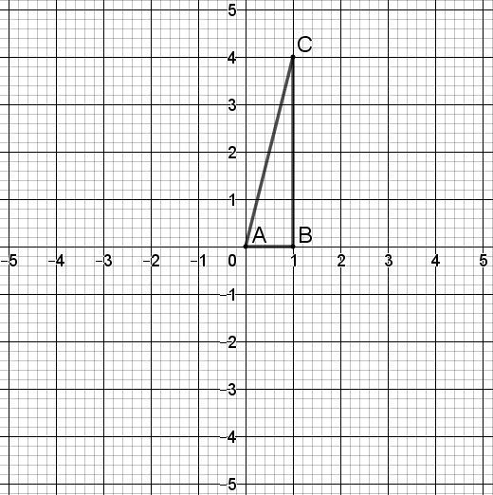

1. The triangle is transformed by a matrix to give an image with vertices , and . Write down the matrix . (2 marks)

|  |
| --- |
| **Solution** |
| is a rotation by , and so |
| **Specific behaviours** |
| 🗸 states transformation or sketches diagram  🗸 states correct matrix |

Question 9 continued

1. Triangle (the **image** from part (a) ) is transformed by a matrix to give an image with vertices , and . Write down the matrix . (2 marks)

|  |
| --- |
| **Solution** |
| is a reflection through , and so |
| **Specific behaviours** |
| 🗸 states transformation or sketches diagram  🗸 states correct matrix |

1. **Hence** write down the matrix which would transform triangle to triangle , showing your working. (3 marks)

|  |
| --- |
| **Solution** |
|  |
| **Specific behaviours** |
| 🗸 multiplies and (in either order)  🗸 multiplies in correct order  🗸 states correct matrix |

1. The triangle is transformed by a matrix to a triangle with coordinates , and . State the value of , given that , justifying your answer.

(3 marks)

|  |
| --- |
| (**Solution** |
| has area and has area .  Hence and since , it follows that . |
| **Specific behaviours** |
| 🗸 determines areas of and  🗸 divides by  🗸 states |

**Question 10 (1.1.1, 1.1.2, 1.1.3, 1.1.4) (6 marks)**

The genetic code is a set of rules defined by the four nucleotides of DNA, represented by the letters A, T, C and G. Three-letter nucleotide sequences are made from the four nucleotides.

1. With no restrictions, how many 3-letter nucleotide sequences are possible in DNA?

(1 mark)

|  |
| --- |
| Solution |
|  |
| Specific Behaviours |
| ✓ correct number |

1. How many 3-letter nucleotide sequences start with A and end with C? (2 marks)

|  |
| --- |
| Solution |
|  |
| Specific Behaviours |
| ✓ uses multiplicative reasoning  ✓ correct number |

1. How many 3-letter nucleotide sequences have a G at least twice? (3 marks)

|  |
| --- |
| Solution |
|  |
| Specific Behaviours |
| ✓ identify two cases  ✓ uses addition principle  ✓ correct number |

**Question 11 (2.3.7-2.311, 2.3.13-2.3.16) (5 marks)**

Consider the following quadratic equation where is a real number.

One of the solutions to this equation is .

1. Write down the other solution of the equation, and plot (and label) both solutions in the complex plane below. (3 marks)

|  |
| --- |
| **Solution** |
|  |
| **Specific behaviours** |
| 🗸 writes correct value for  🗸 plots and labels in correct position  🗸 plots and labels in correct position |

1. Hence (or otherwise) determine the value of . (2 marks)

|  |
| --- |
| **Solution** |
|  |
| **Specific behaviours** |
| 🗸 multiplies and 🗸 states |

**Question 12 (2.1.1-2.1.2, 2.1.9) (9 marks)**

A roofing panel with the dimensions shown below has been left on the ground. An ant is walking across the top of the panel from the left end to the right end.

1. Write a function in the form

modelling the height that the ant is above the ground in terms of the horizontal distance that the ant is from the left end of the panel. Specify the domain of the function. (Assume the panel has negligible thickness.) (3 marks)

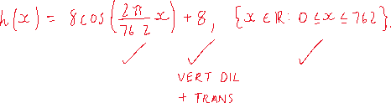

1. Graph the function on the axes below. (3 marks)

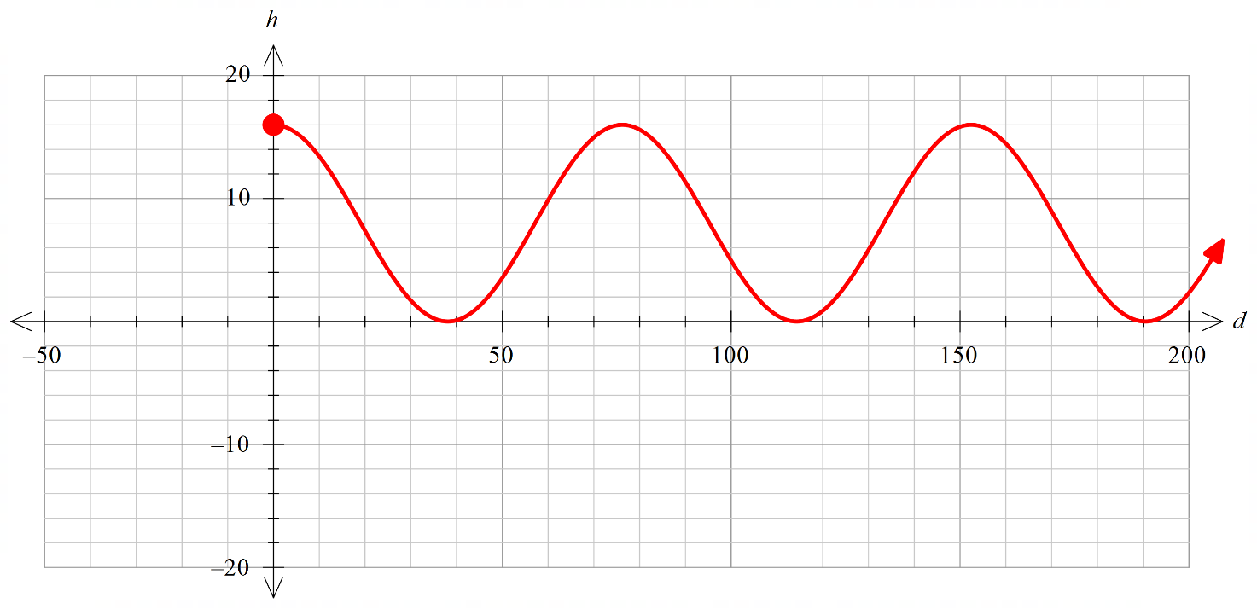

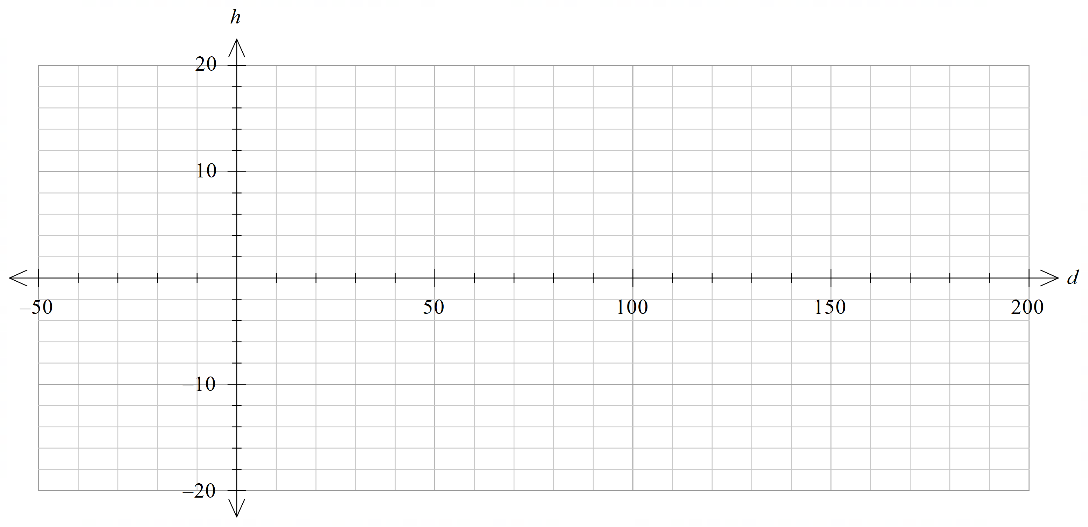

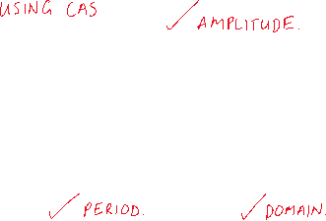

1. The ant gets tired and stops to rest the third time he is climbing at a height of . How far (horizontally) does he have left to walk? (3 marks)

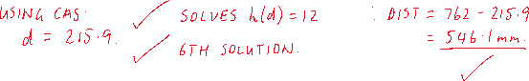

**Question 13 (2.1.4) (7 marks)**

1. Describe the transformation of to . (2 marks)



1. Sketch on the graph shown, **labelling all key features**.

(5 marks)

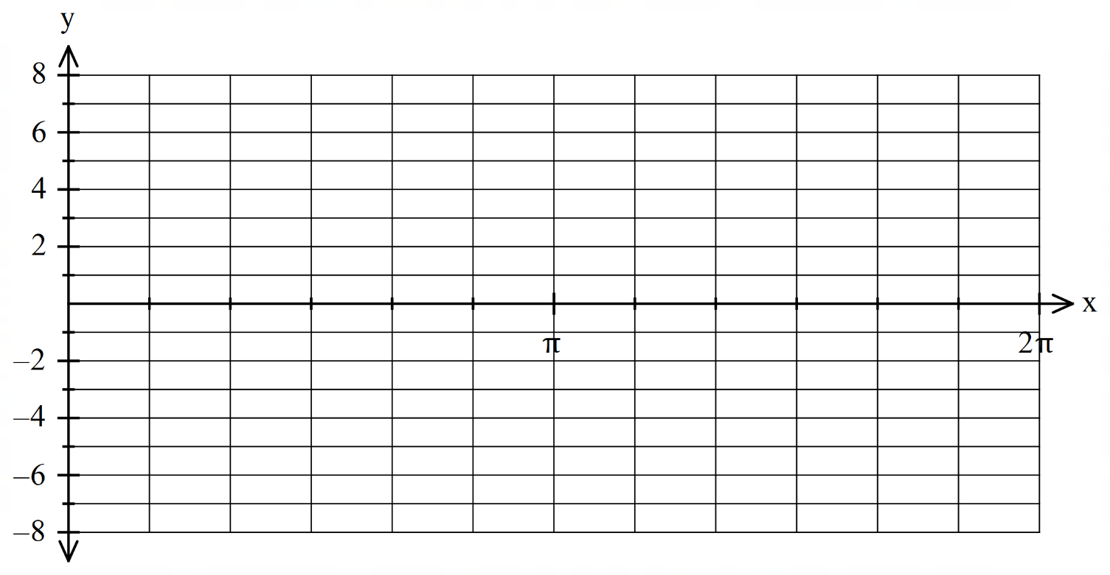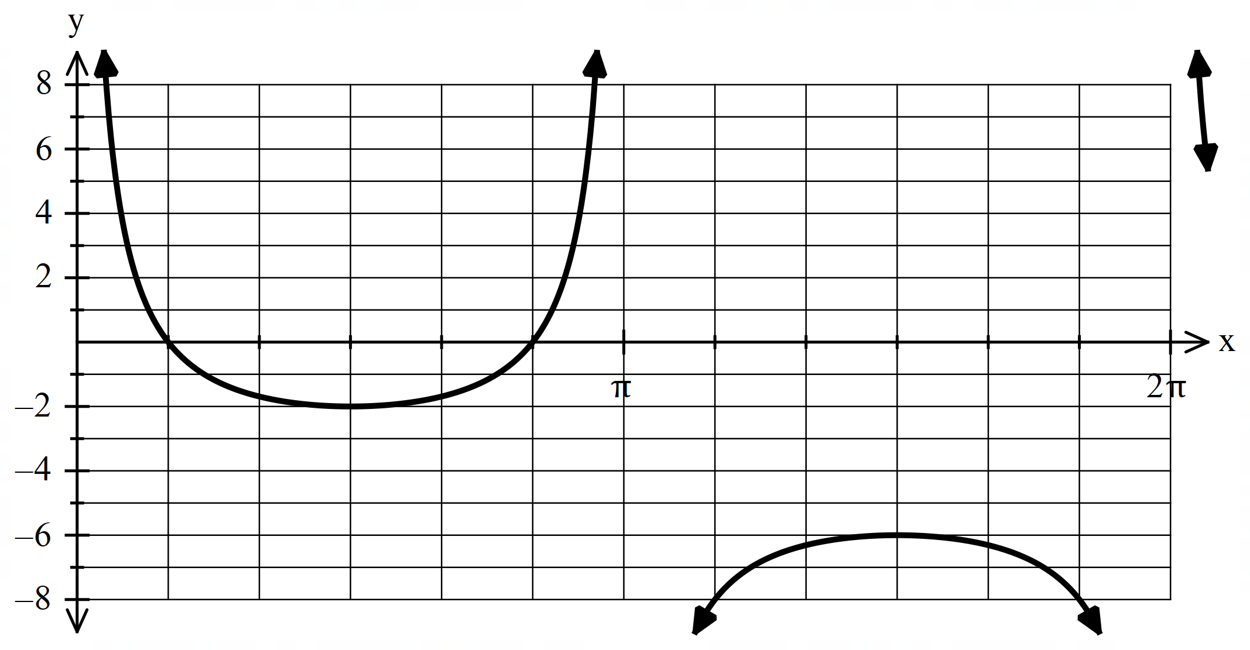

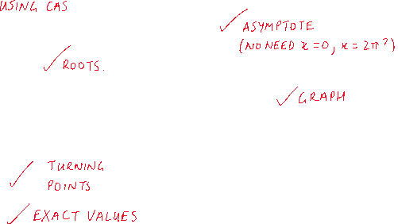

**Question 14 (1.2.6-1.2.13) (10 marks)**

1. Three vectors are given by and where is a constant.
   1. Determine the vector projection of on (give components as exact values).

(3 marks)

|  |
| --- |
| **Solution** |
|  |
| **Specific behaviours** |
| * States unit vector for * States * States projection as a vector |

* 1. Find if the angle between and is . (3 marks)

|  |  |  |  |  |  |
| --- | --- | --- | --- | --- | --- |
| |  | | --- | | **Solution** | | or | | **Specific behaviours** | | * Uses scalar product * States one solution * States second solution | |  |

1. Vectors and are perpendicular. Find the value(s) of and the corresponding pairs of vectors. (4 marks)

|  |
| --- |
| **Solution** |
| or  , the vectors are and  , the vectors are and |
| **Specific behaviours** |
| * Uses (dot product = 0) to form quadratic equation * Solves for two values of * States one pair of vectors * States two pairs of vectors |

**Question 15 (1.3.6-1.3.15) (10 marks)**

1. Consider the diagram below. and are diameters of the circle with centre , and lies on the circumference of the circle such that .

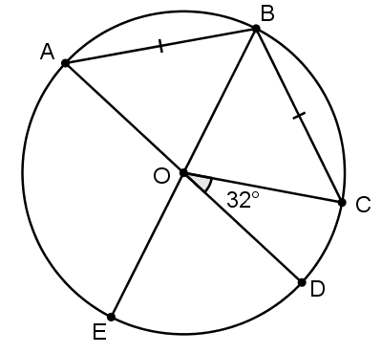

Determine the sizes of the following angles

1. (2 marks)

|  |
| --- |
| **Solution** |
|  |
| **Specific behaviours** |
| * Uses congruent angles * Calculates angle |

1. (3 marks)

|  |
| --- |
| **Solution** |
|  |
| **Specific behaviours** |
| * Indicates size of * Uses relationship between angle at centre and at circumference * Calculates angle |

1. In the diagram below, is the single point of intersection of the two circles. The segment is tangent to both circles, intersecting with the circles at and . Segment is also tangent to both circles, intersecting with at . Prove that is a right triangle. (5 marks)

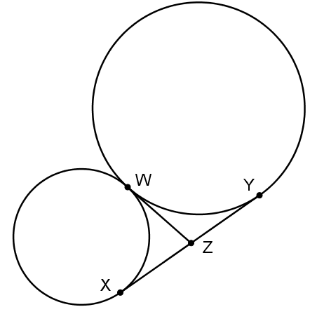

|  |
| --- |
| **Solution** |
| and(tangents from a common point)  Hence , and lie on a circle with centre .  is a diameter of this circle and so is an angle in a semicircle.  Hence .  It follows that is a right triangle. |
| **Specific behaviours** |
| * Notes that * Gives reason for above * States that , and lie on a circle with centre * States that is an angle in a semicircle * Concludes that |

**Question 16 (1.2.2, 1.2.8, 1.2.14) (6 marks)**

Three forces act on the point as shown. What is the magnitude of the resultant force acting on , and in what direction would move under these three forces?

Give your answers to 2 decimal places, with the direction as an angle measured anticlockwise from the right (like the angle for Force 1).

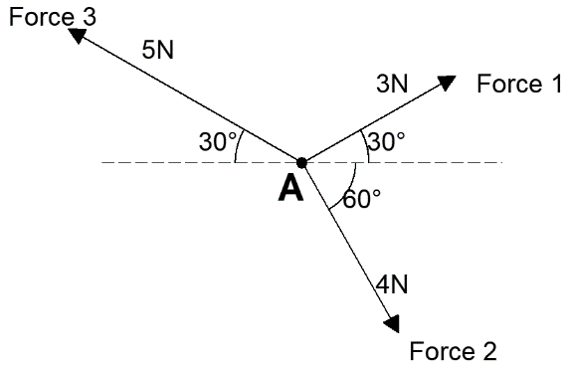

|  |
| --- |
| **Solution** |
| Force 1  Force 2  Force 3  Resultant force:  Magnitude of force:  Direction of force:  Therefore the direction is |
| **Specific behaviours** |
| 🗸 writes correct vector expression for at least one force (accept expressions using polar angles e.g. Force 2 )  🗸 writes correct vector expressions for at least two forces  🗸 writes correct vector expressions for all three forces  🗸 determines vector expression for resultant force  🗸 states correct magnitude of resultant force  🗸 state correct direction of resultant force |

**Question 17 (2.2.1, 2.2.2) (6 marks)**

1. Given invertible matrices , , and with , write in terms of , and .

(3 marks)

|  |
| --- |
| **Solution** |
|  |
| **Specific behaviours** |
| 🗸 collects terms with on LHS  🗸 factorises out **on the right**  🗸 multiplies both sides by |

1. Solve the following matrix equation for

(3 marks)

|  |
| --- |
| **Solution** |
|  |
| **Specific behaviours** |
| 🗸 factorises out on the left  🗸 evaluates  🗸 multiplies both sides by and obtains correct answer |

**Question 18 (1.1.7, 1.1.8) (8 marks)**

Four Year 10 students and eleven Year 11 students from Western Australia are nominated as candidates for a Mathematics Summer Camp. How many ways can a group of four participants be selected:

1. without restriction? (2 marks)

|  |
| --- |
| Solution |
|  |
| Specific Behaviours |
| ✓ correct expression  ✓ correct number |

1. if the only student from Bunbury must be included? (2 marks)

|  |
| --- |
| Solution |
|  |
| Specific Behaviours |
| ✓ correct expression  ✓ correct number |

1. if there must be exactly two Year 11 students? (2 marks)

|  |
| --- |
| Solution |
|  |
| Specific Behaviours |
| ✓ correct expression  ✓ correct number |

1. if there must be at least one Year 10 student? (2 marks)

|  |
| --- |
| Solution |
|  |
| Specific Behaviours |
| ✓ correct expression  ✓ correct number |

**Question 19 (1.1.5, 1.1.9) (8 marks)**

1. How many integers between 1 and 101 are multiples of 5, 6 or 7? (4 marks)

|  |
| --- |
| Solution |
| Multiples of  Multiples of (rounded down)  Multiples of  Multiples of and  Multiples of and  Multiples of and  Multiples of and  Multiples of or |
| Specific Behaviours |
| ✓ finds multiples of 5, 6, 7 respectively  ✓ finds multiples of 30, 35, 42 respectively  ✓ uses inclusion-exclusion principle  ✓ correct number |

1. Use the fact that to show that . (4 marks)

|  |
| --- |
| Solution |
|  |
| Specific Behaviours |
| ✓ uses  ✓ writes  ✓ multiplies by  ✓ writes |

**Question 20 (2.2.1-2.2.10) (8 marks)**

Let .

1. Calculate (that is, ). Show working and simplify your answer. (3 marks)

|  |
| --- |
| **Solution** |
|  |
| **Specific behaviours** |
| 🗸 writes unsimplified product (2nd line) with at least 2 entries correct  🗸 writes unsimplified product (2nd line) with all entries correct  🗸 simplifies using double angle formulas |

1. Calculate the product by multiplying your answer to part (a) by (you do not need to simplify your answer). (2 marks)

|  |
| --- |
| **Solution** |
|  |
| **Specific behaviours** |
| 🗸 at least 2 entries correct in product  🗸 all entries correct in product |

1. Determine a value of (with ) such that . Justify your answer by referring to the linear transformation corresponding to the matrix . (3 marks)

|  |
| --- |
| **Solution** |
| If then .  Since represents a rotation by , represents 3 rotations by applied in sequence; that is, is a rotation by . Thus if , is a rotation by , which is equivalent to a rotation by , and therefore . |
| **Specific behaviours** |
| 🗸 states  🗸 notes that represents a rotation by  🗸 notes that is 3 rotations by , or a single rotation by |

Question 21 (1.2.2, 1.2.3, 1.2.7, 1.2.9, 1.2.14) (7 marks)

An octopus, which can swim with a steady speed of 3.5 m/s through still water, leaves its home at to visit a sea anemone at .

The position vector of relative to is m, and a current with velocity m/s is flowing.

1. Find the velocity vector , in the form , that the octopus should aim to swim with in order to reach the sea anemone in the shortest possible time. (Give and to 2 decimal places.) (5 marks)

|  |
| --- |
| **Solution** |
| We require  so  We also know that  Solving these three equations simultaneously and taking the solution with gives |
| **Specific behaviours** |
| 🗸 equates sum of and current velocity to **a scalar multiple of** displacement vector  🗸 equates components to get 2 linear equations  🗸 states equation  🗸 states at least one of and  🗸 states (i.e. solution corresponding to positive value of ) |

1. Determine the time taken (to the nearest second) for the octopus to reach the sea anemone if it aims to swim with the velocity found in part (a). (2 marks)

|  |
| --- |
| **Solution** |
| EITHER  (from part (a))  Hence total time will be  OR  Horizontal component of resultant velocity  s  OR  Total time s |
| **Specific behaviours** |
| 🗸 shows appropriate calculation  🗸 states 261 s or 262 s |

**END OF QUESTIONS**

Additional working space

Question number:

Additional working space

Question number:

Additional working space

Question number: